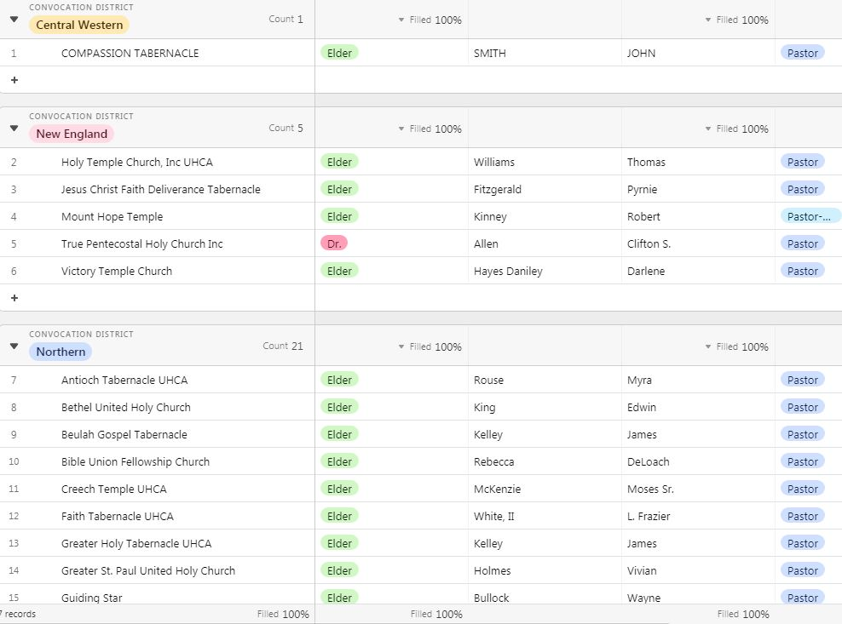**Stand up and be counted…**

**The United Holy Church is moving forward with our statistical data. We need every district to submit your district officer information on our database as well as your local church information.**

**We want our great historical church to have one of the best databases and source of information than any other reformation.**

**You can access the links on the UHC website, or you can type the links below into your computer browser and complete the questionnaire. You can also email me and I will forward the links directly to you. It only takes a few minutes and you’re done. Your District Secretary should be completing the district officer data. Your church Pastors or church secretaries should be completing the local church information.**

**This will take our record keeping to the next level. Your cooperation and compliance are needed. *Let’s get your church on the map today!!***

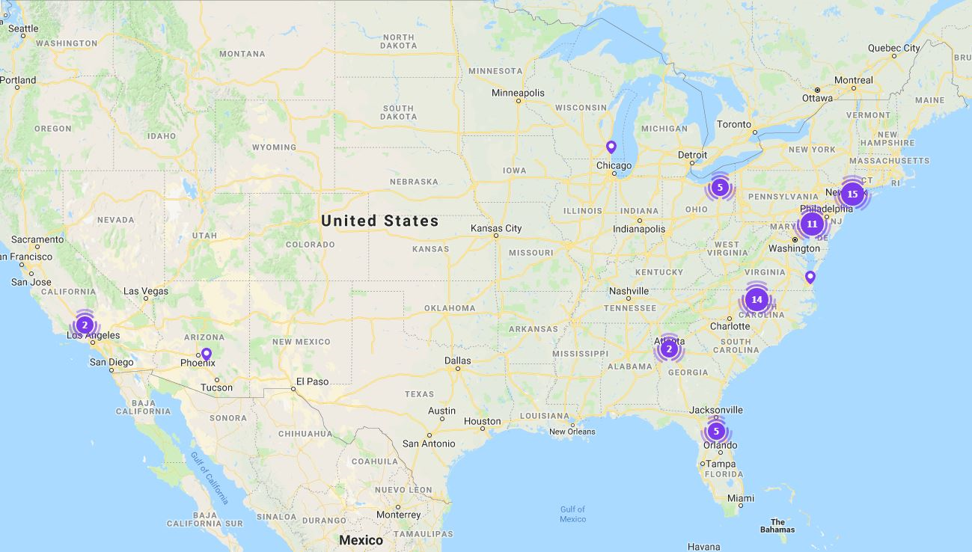

**District Link:**

[**https://airtable.com/shrgVpokPOCto9OLc**](https://airtable.com/shrgVpokPOCto9OLc)

**Church Link:**

[**https://airtable.com/shrf8K0lhpQ7HsrBB**](https://airtable.com/shrf8K0lhpQ7HsrBB)

**In His Service,**

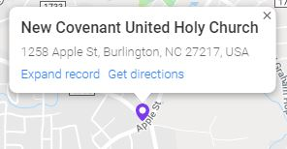

**Milton Douglas**

**General Statistician**

[**Uhc.stats@optimum.net**](mailto:Uhc.stats@optimum.net)